BU hosts a Meeting for EOA throughout Zoom Application

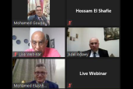
Prof. Dr. Nasser El Gizawy, Benha University Vice-president for Post Graduate Studies and Researches ' Affairs said that the Department of Orthopedic at the Faculty of Medicine has organized the monthly medical meeting of the Egyptian Orthopedic Association "EOA" throughout Zoom application which discussed 20 different cases of orthopedic diseases and surgery.
It is worth mentioning that the meeting has been hold under the patron of Prof. Dr. Gamal El Saeed, the University President and attended by Prof. Dr. Gamal Eladawy, the Former Minister of Health and the Emeritus Professor at the Faculty of Medicine; Prof. Dr. Gamal Hosni, the Head of EOA; and Prof. Dr. Mustafa Elkady, the Dean of the Faculty.

