CSC grants the Distinguished Student Award 2019 to a Researcher from Benha University

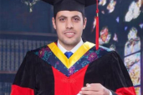
Prof. Dr. Nasser El Gizawy, Benha University Vice-president for Post Graduate Studies and Researches ' Affairs said that the China Scholarship Council (CSC) has granted the Distinguished Student Award 2019 to the Researcher/ Ibrahim Khalifa, the Lecturer at the Department of Food Industries at the Faculty of Agriculture in Moshtohor.
It is worth mentioning that Khalifa had been granted a scholarship to get the PhD from Central China University upon cooperation with Benha University in the duration from 2016 to 2019.

