El Saeed congratulates President El Sisi on July 23rd Revolution

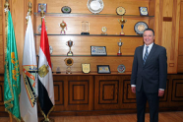
Prof. Dr. Gamal El Saeed, Benha University President has sent a congratulatory message to President Abdel Fattah El Sisi on the occasion of July 23rd Revolution Anniversary.
The message has included "it gives me and Benha University family much pleasure to congratulates your Excellency on the occasion of the 68th anniversary of 23rd Revolution May God Almighty bless you and support you".

