Online Workshop on Using Dar Almandoumah Databases through EKB

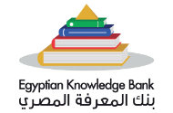
In the frame of Benha University's keenness to develop the abilities of faculty members, researchers, and students in research skills at the databases of the Egyptian knowledge Bank "EKB"; an online workshop about using Dar Almandoumah databases through EKB will be held for the University members on Thursday, July23, 2020 at 10:00am.

