El Gizawy inspects the Postgraduate Studies' Exams

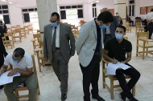
Prof. Dr. Nasser El Gizawy, the University Vice-president for Post Graduate Studies and Researches' Affairs has inspected the conduct of postgraduate studies' exams at the Faculties of Physical Education, Veterinary Medicine, and Law in the presence of Prof. Dr. Mohamed Ghanem, the Dean of the Faculty of Veterinary Medicine; Prof. Dr. Osama Salah, the Dean of the Faculty of Physical Education; Prof. Dr. Reda Abdel Halim, the Dean of the Faculty of Law; and the Vice-deans.

