Benha University Students participates in "We Are All One" Initiative
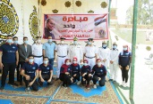
Benha University students have participated in "We Are All One" Initiative launched by the Ministry of Interior upon the recommendations of the Political Leadership to take the necessary actions to support the social protection system for citizens. The students have been participated in the Initiative under the sponsorship of Prof. Dr. Gamal El Saeed, the University President and Prof. Dr. Hussien Almaghrabi, the University Vice-president for Education and Students` Affairs.

