Benha University launches E-services to face Coronavirus

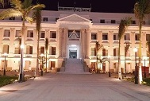
Prof. Dr. Gamal El Saeed, Benha University President said the University has launched group of e-services for students, graduates, and postgraduates aiming to facilitate all university services remotely in the frame of facing the spread of novel Coronavirus and within the digital information policy of the University.

