Online Workshop about Egyptian Knowledge Bank Services

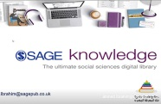
Post Graduate Studies Sector organized online workshop about Egypt Knowledge Bank services. The Workshop was held by cooperation with Sage Knowledge and under auspices of Dr\ Gamal El Saeed, Benha University President, Prof.Dr.Nasser El Gezawy, Benha University Vice-President for Post graduate Studies and Scientific Research and by participation of 52 FM staff.Prof.Dr.Nasser El Gezawy said that the Workshop aims to raise awareness of activating the use of publications and resources on the Egyptian Knowledge Bank as the biggest digital library in the world.

