Benha University President Honors Dr\ Amr Hanafy

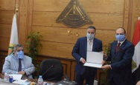
Benha University Council under presidency of Dr\Gamal El Saeed, Benha University President honored Dr\Amr Hanafy, Head of Surveying Department at Shoubra Faculty of Engineering for his efforts to limit spread of Corona Virus after his participation at the National Planning center. Dr\Amr Hanafy has designed a digital system to follow Corona Virus spread in Egypt according to districts and governorates and to know numbers of infected and death people.

