Benha University among the Best 100 Universities According to Times Sustainable Development Ranking 2020
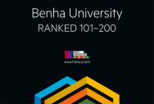
Dr\Gamal El Saeed, Benha University President announced that Benha University has achieved a leading position at Times Sustainable Development Ranking 2020. Benha University was ranked for the first time among the top 101-200 Universities in the world for emerging economies. The University President congratulated all the staff at the University for that great success and mentioned that the progress and achievement has been achieved according to the University policy to improve and develop the educational process, motivating scientific research, supporting and improve the output of international publishing, consequently that reflected on creating a new generation of inventors, outstanding innovators, researchers and teaching staff.

