Benha University President inspects Faculties of Physical Education and physical therapy

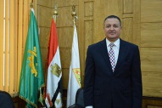
Prof.Dr.\ Gamal El Saeed, Benha University President has inspected faculties of Physical Education and physical therapy at Kafr Saad. El Saeed was accompanied by Prof.Dr.\ Hussein El Maghraby, the University Vice-president for Education and Students' Affairs, Prof.Dr. Randa Mohamed Ahmed Mustafa , Benha University Vice- President for Community Service Affairs and Dr.\ Walid Tallat , Faculty of Physical therapy dean . El Saeed inspected halls, offices and medical supplies .El Saeed also inspected faculty of Physical Education and its halls, supplies, playgrounds, maintenance works.

