Benha University keeps in touch with Wuhan University to Face Corona Virus

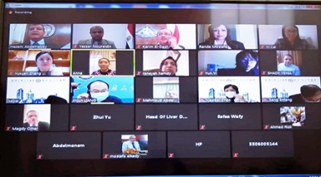
Dr\Gamal El Saeed , Benha University President assured on the necessity of activating international relationship between Benha University and Wuhan University to benefit from their experience at facing Corona Virus and the used medication method to reduce the severity of Corona Virus .He also added that a meeting via video conference system between medical teams which included; 10 professors from Benha University and six professors from Wuhan University had been held to transfer Chinese experiences in confronting Corona virus in terms of diagnostic methods, isolation, preventing the spread of infection within society and how to protect medical teams as well as the adopted methods of treatment in accordance with the Chinese medical protocols, which have proven its effectiveness
in the last experiments.

