New Appointments at Benha University

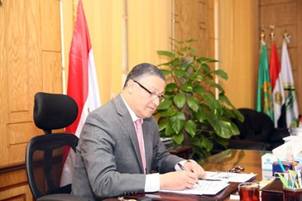
Dr\ Gamal El Saeed, Benha University President has issued several decrees to appoint faculties' deputies and departments' heads. The issued decrees included; Dr\Samy Mohamed Ahmed Ghonimy as Faculty of Commerce deputy for Education and Students Affairs , Dr \ Mohamed Ahmed Ibrahim Khalil as Faculty of Commerce deputy for Community Service and Environment Affairs , Dr\ Ahmed Bayoumy as the manager for E- Learning Center and Dr\ Mona Mohamed as the manager for Information Technology Unit at the University.

