Benha University is one the best three universities in the contest of developing the squatters areas

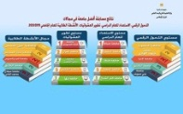
Prof.Dr. Gamal EL-Saeid, the university president announces that Benha University obtains the 3rd place in the contest of developing the squatters’ areas. This contest is held in response to his Excellency Mr. president/ Abd el-Fattah EL-Sisi’s initiative to magnify the role of the universities in the society to develop the squatters’ areas.

