An orientation session conducted in Benha University about the scholarships of the European Union program to support the higher education
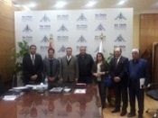
The international relationships office holds an orientation session conducted in Benha University about the scholarships of the European Union program to support the higher education. This orientation session is held in cooperation with the Erasmus plus/ Egypt to help the university’s policy of openness toward the globe.

