El Qalyoubia's Governor and Benha University President witness Faculty of Arts Accreditation Ceremony

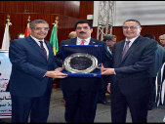
Dr\Alaa Abd El Halim, El Qalyoubia's Governor and Dr\Gamal El Saeed, Benha University President witnessed the organized ceremony by Faculty of Arts on the occasion of getting accreditation by the National Authority for Quality Assurance and Accreditation of Education. The Ceremony was held in presence of Prof.Dr\ Hussein El Maghraby, the University Vice-president for Education and Students' Affairs and Dr\Abeer El Rabat, the Faculty dean. The Governor in his word congratulated Benha University president and hoped for Benha University the best place among world universities.

