Benha University Leaders congratulate the University on the Occasion of Ramadan 1440H

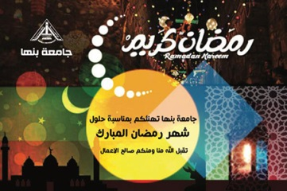
Prof. Dr. Gamal El Saeed, the President of Benha University; Prof. Dr. Hussein El Maghraby, the University Vice-president for Education and Students' Affairs congratulate the faculty members, employees, and students on the occasion of Ramadan 1440H …. Wishing the Blessings of Allah Fill our Life and our beloved Egypt with Peace, Joy and Prosperity. Happy Ramadan

