EL-Kady congratulates the new University president for being in charge

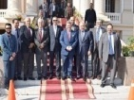
Prof.Dr. Gamal EL-Saied, the new university president hosts, in his office, prof.Dr. EL-Sayed EL-Kady, the former university president to congratulate him for being in charge. EL-kady expresses his happiness for appointing prof.Dr. EL-Saied as the university president wishing him success and progress

