"10 indicators to measure the application of the quality systems criteria in Benha University" says EL-Magraby

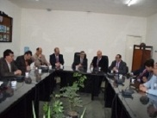
prof.Dr .Hussien Magraby, the university president goes in a tour to inspect the faculty of agriculture and the faculty of veterinary medicine in the presence of prof.Dr. Mahmoud Eraqi, prof.Dr. Muhammad Ghanem and prof.Dr. Naser El-giaway. He says that the university has determined ten indicators to measure the application of the quality systems criteria.

