"Scientific research and international cooperation are the main pillar to cope up with the developed countries" says EL-Magraby in accordance with launching the Egyptian satellite

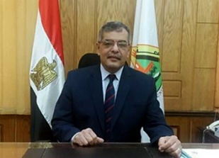
prof.Dr .Hussien Magraby, the university president stresses that Egypt seeks to cope up with the developed countries regarding the field of science and scientific research. This is evident in the efforts being exerted by the state in the last few years pinpointing that scientific research is the main pillar for the development with which the society can solve its problems

