"Education is considered as an investment in the man" says the secretary of the Arab Universities Union

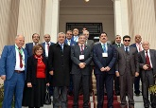
Prof.Dr. Abd EL-Reheim EL-Henity, the assistant general secretary of the Arab Universities Union says that the union has launched many projects which aim at developing the higher education by holding many workshops and courses that enhance the quality of education. He also stresses that education is considered as an investment in the man

