The faculty of veterinary medicine participates in the workshop of the international organization for animal health

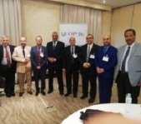
Prof.Dr. Muhammad Ghanem, the faculty's dean participates in the first workshop toward the international accreditation which was held by the faculty of veterinary medicine at Jordan in cooperation with the international organization for animal health from 5 to 6 December in Cairo.

