Benha University president holds an introductory session of Egypt prize contest that was launched by his Excellency Mr. Abd EL-Fattah EL-Sisi

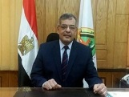
Prof.Dr. Hussien Magraby, the acting university president urges the students of the university to effectively participate in the contest of Egypt prize of the governmental services applications of the universities’ students. This initiative is launched by Mr. President/ abd Fattah EL-Sisi in Cairo international fair of communications.

