Bejin university stduents delegation end their visit to benha university

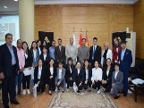
Bejin university students delegation ends their visit to benha university as they visit many university's faculties to get to know the these faculties and it programs. Prof.Dr Hussien EL-Magraby, the acting university president says that this visit comes in accordance with many protocols that the university has signed with a lot of chinese universities to exchange the faculties' members and the students.

