" the university totally supports the stduents' union" say EL-magraby in his first metting of the university's students' union

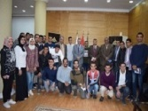
Prof.Dr. Hussien magraby, the acting university president meets with the head and the members of the university's students' union in presence of prof.Dr. Khalid Esawai, prof.Dr. Ezat EL-khait, prof.Dr. Muhammad Gowda and prof.Dr. Moshbeh EL-Kheliy. The university president stresses that the university totally supports the students' union

