The faculty of veterinary medicine organizes many workshops to hone the capabilities of the faculties’ members in the scientific projects in cooperation with the German authority of scientific exchange

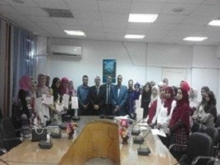
The faculty of veterinary medicine organizes many workshops to hone the capabilities of the faculties’ members in the scientific projects in cooperation with the German authority of scientific exchange. These workshops are designed for hone their capabilities regarding the scientific writing and problem- solving techniques..

