Benha University holds an introductory forum about its new programs

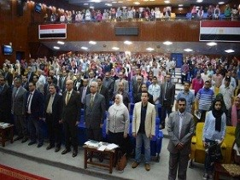
Benha University organizes, under the auspices of Prof.Dr. Hussien EL-Magraby, the acting president of Benha University, an introductory forum about its new programs. This forum is attended by prof.Dr. Hesham Abu el-Enin, the faculties’ deans and the faculties’ members, the stduents and the alumni.

