Top positions of Benha University's students in the different student activities

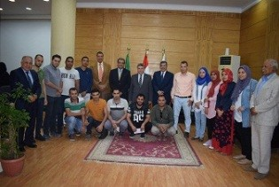
Prof.Dr. Khalid Esawi, the supervisor of the stduents' activities thanks prof.Dr. El-Sayed EL-Kady for his support to the students' activities. He says that the university supports the students' activities with 2 million pounds and Benha University has achieved many top positions in the different aspects.

