Benha University is in higher education fair

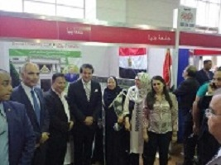
Benha University&#39;s section that was inaugurated by prof.Dr. Khalid Abd EL-Gafer, the minister of higher education, achieves great success. There are many visitors who pays a visit to the fair that 50 universities take part in. the visitors are very keen on let their sons get enrolled in the faculties of Benha University

