The meeting of the executive bureau of Benha University's strategic planning unit

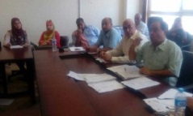
The executive bureau holds its meetings, on wendesday, under the presidency of prof.Dr. Gamal Abd El-Aziz, the head of the strategic planning unit. The meeting is attended by the unit's chancellors, the committees' secretaries and the heads of the strategic planning units in the university

