The future of the veterinary medicine is discussed in Benha University’s conference tomorrow

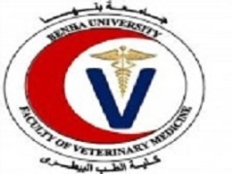
Prof.Dr. EL-Sayed el-Kady, the university president inaugurated the conference of the veterinary medicine that will last for 4-8-2018. This scientific conference is entitled “the future horizons of the veterinary medicine in the consistent development”

