El-Magraby inspects the amendments in the faculty of applied arts

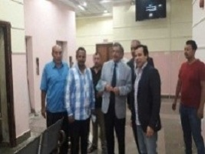
Prof.Dr. Hussien EL-Magraby, the acting president of Benha University inspects the amendments of the lectures halls in the faculty of applied arts in addition to inspecting the construction of an entrance of the faculties of the applied arts and the computer and informatics.

