“2019 is the year of the education and scientific research” says the president of Benha University

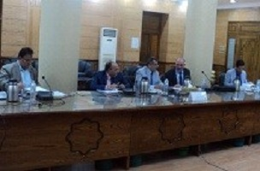
The meeting of post-graduate council has been held on Tuesday under the presidency of prof.Dr. Hussien EL-Magraby to make sure that everything is up and running for the new academic year and discussing the plans of the post-graduate sector in the faculties. The university president says that the year of 2019 is the year of education and scientific research.

