Initaiting the common project between benha University and China to save 30% of rice's irritation water

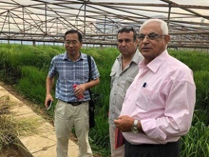
In a meeting between benha University 's delegation and the professor, Cheng youngzong, it has been agreed upon a schedule to initiate the common project between benha University and China to save 30% of rice's irritation water

