2 million pounds for the young researchers in benha University

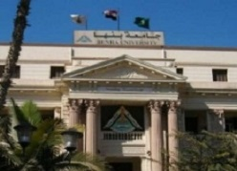
Prof.Dr. EL-Sayed EL-Kady, the university president declares the university will grant the young researchers 2 million pounds to fund seven researches in the field of reinforcing the big natinoal projects.

