EL-kady decides to declare the emergency status in the University’s hospitals and issuing a decree to make the medical examination for free in the hospitals
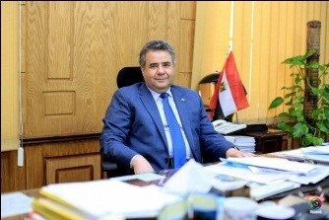
Prof.Dr. EL-Sayed El-kady, the university president decides to declare the emergency status in the University’s hospitals and issuing a decree to make the medical examination for free in the hospitals during all days of Eid-EL-Adha.

