The final result of the citation competition of January 2018

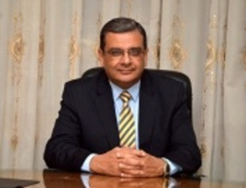
Prof.Dr. Hesham Abu EL-Enin, the vice president of post-graduate studies and research that the supreme council of the international ranking, under the auspices of prof.Dr. EL-Sayed EL-Kady has endorsed the final result of the citation competition through Google scholar

