Declaring the state of emergency in Benha University’s hospitals

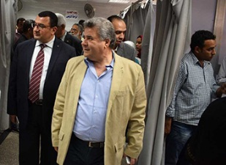
Prof.Dr. EL-Sayed EL-Kady, the university president decides to declare the state of emergency in Benha University’s hospitals starting from today till the end of the feasts. This decision concurs with his sudden tour with the general / Ahmed Zaglol, the assistant of the ministry of health and prof.Dr. Hossam Abd EL-Azim, the head of the board of hospitals as he inspects many departments in Benha University’s hospitals.

