The faculty of specific education in Benha University to be sent to the village of EL-Sheikh Ibrahim

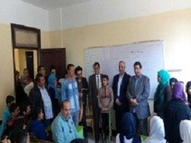
The faculty of specific education in Benha University organizes a convoy to the village of EL-Sheikh Ibrahim and it is attended by prof.Dr. Gamal Ismail, the vice president of the community service and environment development and prof.Dr. Gamal Sosa, the faculty’s dean. The convoy has done many activities that may enhance the village on different apparatus.

