A forum entitled “youth and the political participation” to be held in the faculty of arts in Benha University

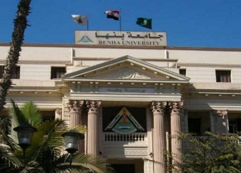
Prof.Dr. EL-Sayed El-kady, the university president and prof.Dr. Abeer EL-Rabat, the dean of the faculty of arts forum entitled “youth and the political participation” in the faculty of arts in Benha University in cooperation with Nile center of Media in Qulubia. Prof.Dr. Ragab Megahed delivers a lecture on the big national projects.

