500 L.E to be paid to the University&#39;s employees

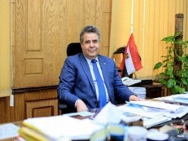
Prof.Dr. EL-Sayed EL-Kady, the university president decides to pay a bonus; 500 L.E to all University&#39;s employees. EL-Kady says that this bonus will be paid form the University&#39;s own resources to keep itself fully committed to the employees in the University.

