EL-Kady witnesses a student experience of managing the crises today

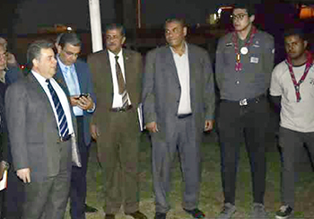
On Thursday morning, Prof.Dr. EL-Sayed EL-Kady, the university president witnesses a student experience of managing the crises. This event is held in the presence of prof.Dr. Gamal Ismail and prof.Dr. Hesham Abu EL-Enin, the faculties ‘deans and the faculties’ members.

