A veterinary convoy to be sent to the village of Asneit from Benha University

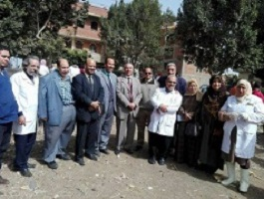
The veterinary convoy has finished its activities in the village of Asneit. The convoy manages to cure 118 animals and 1630 birds. This statement concurs with what prof.Dr. Muhammad Muhammady Ghanem, the faculty&#39;s deans has said. Ghanem says that this convoy comes in the frame of the university to preserve the animal stock and guiding the citizens to take care of the animals and birds.

