EL-kady goes on a tour to inspect the first day of academic year
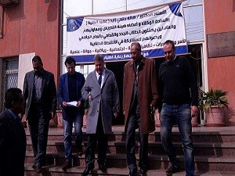
Prof.Dr. EL-Sayed EL-kady, the university’s president pays a visit to the faculty of computer and informatics and the faculty of applied arts to inspect the first day of the academic year. The university president listens to the faculties’ deans about the preparations that have been done to welcome the students in the new Term.

