The inauguration of Benha University’s exhibition at lower costs
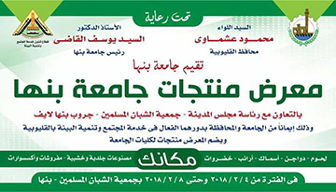
General/ Mahmoud Ashmawy, the Qulubia governor and prof.Dr. EL-Sayed EL-Kady, the university’s president inaugurates the university’s products exhibition that is held in cooperation with the Qulubia governorate to provide different products to the citizens at lower costs.

