17.6 million L.E paid form the ministry of finance to Benha University’s hospital
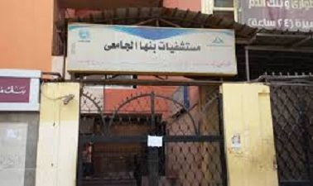
The ministry of finance approves to provide the university’s hospital with the money needed to get the drugs and the medical requirements needed to provide quality healthcare services to the citizens. The ministry pays 17.6 million L.E according to what the university’s assistant secretary of the financial affairs has said.

