The faculty of veterinary medicine organizes a training day for the students in the educational hospital
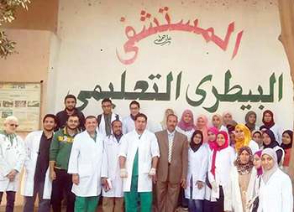
The faculty of veterinary medicine organizes, under the auspices of prof.Dr. Prof.Dr. EL-Sayed EL-Kady and prof.Dr. Gamal Ismail, a training day for the students in the educational hospital which welcomes the inhabitants of Toukh to treat the animals and the birds.

