Activating the role of anti-corruption committee in Benha University
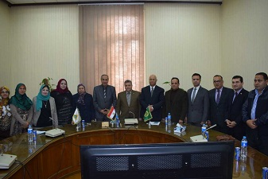
Prof.Dr. EL-Sayed EL-Kady, the university president decides to activate the role of the anti-corruption unit in the university by establishing many units in the different faculties. This concurs with the meeting between the University president and prof.Dr. Gamal Sosa, the head of central unit in addition to the members of the unit and the university’s assistant secretaries.

