An important statement of Benha University
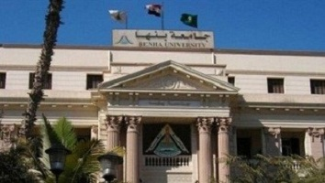
Benha University keeps a close eye on the reactions aroused around the question of the second grade at the department of media in the faculty of arts. This question is an optional one in the question booklet. The University seeks to respect all the opinions in which people feel annoyed of this question. The University seeks to make sure that prof.Dr. EL-Sayed EL-kady, the University president has asked the faculty’s dean to ask the professor of his motifs to include this question in the questions booklet and the professor says that he has no bad intentions regarding this question. The professor intends to train students on how to write an essay and criticizes it as they are the media leaders in the future.

