El-Kady inspects the exams in three faculties in Benha University
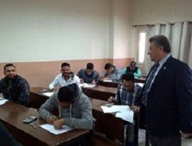
Prof.Dr. El-Sayed El-kady, the University president inspects the exams in three faculties in Benha University as he goes to the faculty of engineering and makes sure that everything is strictly up and running. He goes to the faculty of veterinary medicine where he is welcomed by prof.Dr. Muhammad Ghanem, the faculty’s dean, prof.Dr. Muhammad Abu Salim, the former dean and the head of the newcomers unit in the University and prof.Dr. Yasser Foaud, the faculty’s deputy of community service and environment development to inspect the exams halls, the veterinary medicine, and the veterinary pharmacy. He ends his tour by visiting the faculty of agriculture where he is accompanied by prof.Dr. Mahmoud EL-Eraqi and then console the death of prof.Dr. Abu baker Zaky, the professor of fruits in the faculty of agriculture.

